**Lab 3**

**Plot of anomalies using Z-score**

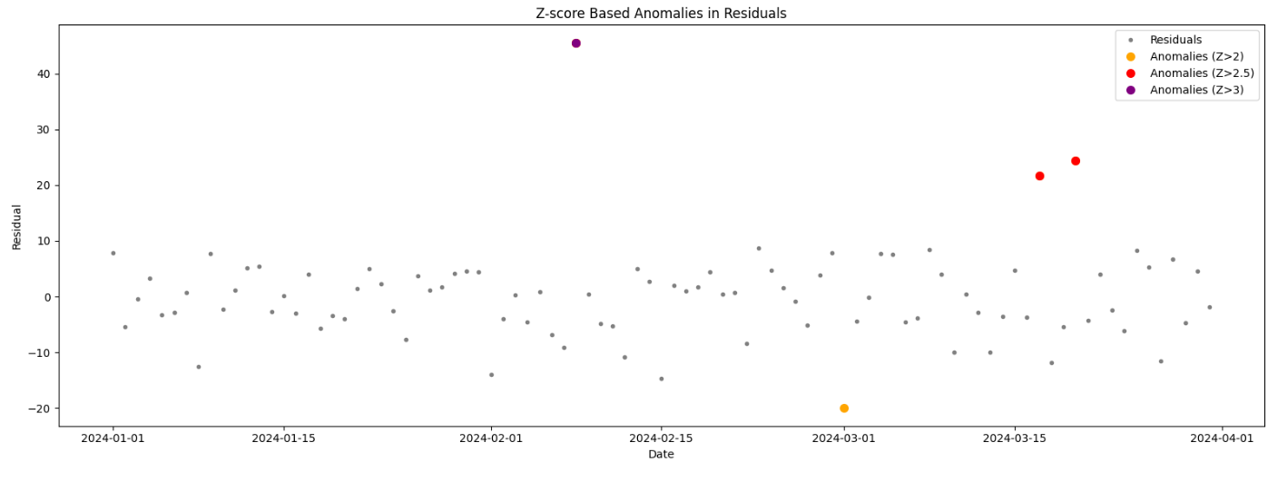

**Plot of anomalies using IQR**

